VM Insights

FAQ and Troubleshooting Guide

URL: <https://aka.ms/vminsightsfaq>

# Onboarding

## General

### Supported VM Operating Systems

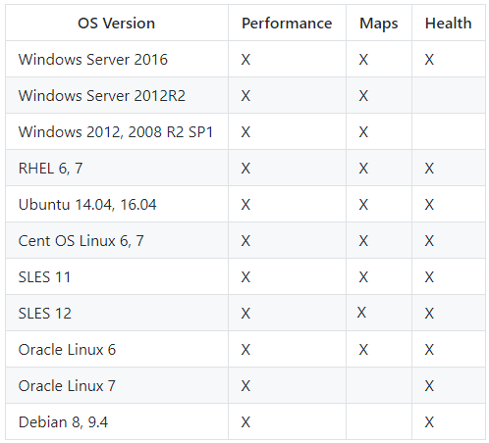

For the latest version of supported systems, please refer to our [onboarding documentation](https://aka.ms/vminsightsinstall).

### Supported Regions

VM Insights supports VMs in any Azure region. It also supports non-Azure VMs (e.g. on premises VMs or hosted with another cloud provided).

We do require that you use a Log Analytics workspace for VM Insights to store the data we collect and monitor. For these workspaces, we support the following Workspace regions.

* West Central US
* East US
* West Europe
* Southeast Asia (the Health component of VM Insights does not support this workspace region yet)

For the latest list of supported regions, please refer to our [onboarding documentation](https://aka.ms/vminsightsinstall).

### Onboarding to an existing workspace

If your VMs are already connected to a Log Analytics workspace you may continue to use that workspace when onboarding to VM Insights, provided it is in one of the supported regions listed above.

When onboarding to VM Insights, we configure performance counters for the workspace that will cause all of the VMs reporting data to the workspace to begin logging this information for display and analysis in VM Insights.

For more information on which performance counters are enabled, please refer to our [onboarding documentation](https://aka.ms/vminsightsinstall).

### Onboarding to a new workspace

If your VMs are not currently connected to an existing workspace you will want to create a new workspace to store your data. This is done automatically if you configure a single Azure VM for VM Insights through the UI experience.

If you choose to use the script based on boarding, these steps are covered in the [onboarding documentation](https://aka.ms/vminsightsinstall).

### Support for On-Premises VMs

Yes, VM Insights supports on-premise VMs as well as VMs that are hosted with another cloud provided. Since it is not an Azure VM, you won’t see the views from the Azure VM menu but you will be able to access all of the information for your VMs from Azure Monitor.

## Onboarding from the VM Blade

### My VM is connected to an existing workspace

There are many scenarios where you may have already configured your VM to report data to an existing Log Analytics workspace. As long as that workspace is in one of our supported regions you can enable VM Insights to that pre-existing workspace. If the workspace you are already using is not in one of our supported regions you won’t be able to onboard to VM Insights at this time. We are actively working to support additional regions.

To note, we do configure performance counters at the workspace level that will take effect on all VMs that report data to your existing workspace whether or not you have chosen to onboard them to VM Insights.

For more details on how performance counters are configured at the workspace level, please refer to our [online documentation](https://docs.microsoft.com/en-us/azure/log-analytics/log-analytics-data-sources-performance-counters).

For information about the counters we configure in VM Insights, please refer to our [onboarding documentation](https://aka.ms/vminsightsinstall).

### I think my VM failed to onboard to VM Insights

When onboarding via the UI, the following steps occur:

* The workspace is configured for VM Insights
* The OMS agent is installed on the VM (if needed)
* The dependency agent is installed on the VM (if needed)
* The VM is configured for health monitoring
* The VM begins to send data to the selected workspace

We check for status on each of the above to return status to you in the UI. Configuration of the workspace and the agent installation typically takes 5 to 10 minutes. Having monitoring and health data available to the UI takes an addition 5 to 10 minutes.

If you have begun onboarding and see messages about still needing to onboard please allow for up to 30 minutes for the VM to fully onboard to VM Insights.

# Onboarding using scripts

## Common errors

**Unsupported OS encountered during onboarding**

If the powershell script encounters a VM with an unsupported OS in the scope defined in the script. If this happens, the powershell script may stop and not progress to additional VMs.

# VM Insights on the VM Blade

## Health

### What VM regions does health support?

Currently Health monitoring is enabled for VMs in WCUS and EUS only, and is slated to expand to support VMs in all regions and LA workspaces in East US, West Central US, and West Europe in the first week of September.

## Known Issues

1. The time period and frequency of health criteria are not editable, they will be made editable in future releases

2. Users can’t disable health criteria

3. After onboarding quite some time is expended before data is populated in Azure Monitor -> Virtual Machines -> VM Health UI or VM resource blade -> VM health UI

4. Health Diagnostics experience updates faster than any other view, so you may experience information log between blades

5. Action groups APIs are working, but action groups aren’t firing at the moment; this feature will be up soon

6. The health criteria knowledge articles are not integrated in the experience, please refer to the Health Criteria Details docs in case of any clarifications on health criteria running.

7. The fired alerts section in the single VM experience shows alerts whose monitor condition is set to “fired” in past 30 days, it is not configurable. Clicking on See more, you can change the filter of Time Range.

8. In the alerts list view page, we suggest not to change the Resource type, Resource and Monitor Service filters as they have been handled specific to the solution.

9. In Linux VMs, health diagnostics view has the entire domain name of the VM instead of the user given VM name

10. Alert History doesn’t update adequately in the alert details blade. 31

11. Fired date is latched to the first time ever the alert was fired in a month. If the same alert becomes active on the same VM again in a month’s window, only last updated date gets updated. Hence, we suggest during private preview filter using last updated date.

12. Unwanted context switches (automatic changes in tab selection) in health diagnostics experience may happen

13. Shutting down VMs, will turn some of its health criteria in critical and others in healthy state with net state of the VM being critical, instead of unknown state

# VM Insights under Azure Monitor

## Maps

### How does the map handle duplicate IPs across different vnets and subnets

If you are duplicating IP ranges either with VMs or VM scale sets across subnets and vnets it can cause the maps to display incorrect information. This is a known issue and we are investigating options for improving this experience.

### When I load a map for a Resource Group or other large group the map is difficult to view

While we have made improvements for handling large and complex maps, our work is not done. Maps that have a lot of nodes, a lot of connections, and node working as a cluster can results in a view that is very large and complex.

In these scenarios, you may want to load a map for a smaller group (e.g. define a computer group for the smaller set of VMs) or for a particular VM in the group.

If you are interested in working with us to improve our support for large and complex maps, please let us know and we can include you in our future preview releases.

### When I navigate to maps nothing ever loads

If you navigate to the maps tab and the page tries to load but never does it could mean that you have not onboarded your workspace to VM Insights yet. This is a known issue, where the map page tries to find an onboarded workspace and never returns a message to the UI. Please confirm that your workspace has been onboarded as described in the [onboarding documentation](https://aka.ms/vminsightsinstall).